**Extended Reality (XR) Capstone - Transition Documentation**

**Table of Contents**

Download and Installation Instructions 1

Steps to Start Running the Project 2

Requirements/Recommendations 3

Download Links 3

Unreal Engine 5 Plugins 3

Documentation References 3

Video References 3

----------------------------------------------------------------------------------------- SECTION BREAK --

# Download and Installation Instructions

1. Download and install the Epic Games Launcher
   1. Open the launcher and create or log in to your Epic Games account.
   2. Navigate to the Unreal Engine tab and click the Install button to download the most recent Unreal Engine version.
2. Download and install Android Studio 4.0
   1. (This will be used to build APK and uploaded to hardware).
   2. Agree to any terms and conditions.
   3. Scroll to Android Studio Release Candidate 4 (May 28, 2020).
   4. Download the installer for your device.
3. Download and install the Oculus PC App
   1. Launch the app and follow through the installation process.
   2. Connect the Oculus headset to the app [Recommended: Link (Cable)].
   3. Follow the on-screen instructions to connect your headset.
4. Download and install Visual Studio Code
   1. Launch the Setup and follow the on-screen instructions.
   2. Install the Python extension for Visual Studio Code.
5. Download and install Python
   1. Check box “Add python.exe to PATH”

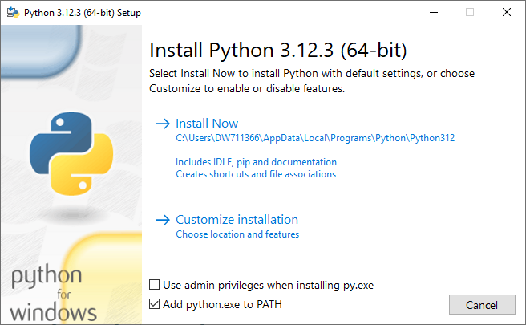

1. Install the NumPy and PySpice libraries through the command prompt
   1. CMD: pip install numpy
   2. CMD: pip install pyspice
   3. CMD: pyspice-post-installation --install-ngspice-dll --ngspice-version=32
2. Download and Install GitHub Desktop
   1. Launch the Setup and follow the on-screen instructions.

----------------------------------------------------------------------------------------- SECTION BREAK --

# Steps to Start Running the Project

[Video Tutorial](https://youtu.be/2KHZwzohu0U)

1. Launch GitHub Desktop and clone the Extended-Reality repository.
2. Locate the local repository and in the “X11823” project folder run the .uproject file.
3. Open the server.py file Visual Studio Code and run the Python file.
4. Launch the Meta Quest Link app and connect your Oculus Headset
5. In the UE5 project, from the Level Editor Toolbar buttons, click on the Play dropdown button to display the Play Options dropdown menu.
6. Select VR Preview and click the Play button to begin a Play In Editor (PIE) session and test gameplay through the headset viewport.

----------------------------------------------------------------------------------------- SECTION BREAK --

# Requirements/Recommendations

* Meta Quest Link Requirements
  + [Window PC Requirements](https://www.meta.com/help/quest/articles/headsets-and-accessories/oculus-link/requirements-quest-link/)

|  |  |
| --- | --- |
| **Component** | **Minimum Specifications** |
| **Processor** | Intel i5-4590 / AMD Ryzen 5 1500X or greater |
| **Graphics Card** | See GPU tables below |
| **Memory** | 8 GB+ RAM |
| **Operating System** | Windows 10, Windows 11 |
| **USB Ports** | 1x USB port |
|  | **Recommended Specifications** |
| **Processor** | Intel i7 / AMD Ryzen 7 |
| **Graphics Card** | Nvidia RTX 20 Series / AMD Radeon RX 6000 Series |
| **Memory** | 16 GB DDR4 RAM |
| **Operating System** | Windows 10, Windows 11 |
| **USB Ports** | 1x USB-C port |

----------------------------------------------------------------------------------------- SECTION BREAK --

# Download Links

[Epic Games Launcher](https://www.unrealengine.com/en-US/download)

[Oculus PC app](https://www.meta.com/help/quest/articles/headsets-and-accessories/oculus-rift-s/install-app-for-link/)

[GitHub Desktop](https://desktop.github.com/)

[Autodesk Fusion 360](https://www.autodesk.com/education/edu-software/overview?sorting=featured&filters=individual)

[Android Studio 4.0](https://developer.android.com/studio/archive)

[Visual Studio Code](https://visualstudio.microsoft.com/)

[Python](https://www.python.org/)

----------------------------------------------------------------------------------------- SECTION BREAK --

# Unreal Engine 5 Plugins

[TCP Socket Plugin](https://www.unrealengine.com/marketplace/en-US/product/tcp-socket-plugin)

----------------------------------------------------------------------------------------- SECTION BREAK --

# Documentation References

[Unreal Engine 5.3 Documentation (or latest)](https://dev.epicgames.com/documentation/en-us/unreal-engine/unreal-engine-5-3-documentation)

[UE5 Introduction to Blueprints](https://dev.epicgames.com/documentation/en-us/unreal-engine/introduction-to-blueprints-visual-scripting-in-unreal-engine)

[Level Editor](https://dev.epicgames.com/documentation/en-us/unreal-engine/level-editor-in-unreal-engine" \l "toolbar)

[In-Editor Testing (Play & Simulate)](https://dev.epicgames.com/documentation/en-us/unreal-engine/in-editor-testing-play-and-simulate-in-unreal-engine#playineditor)

[Set up Meta Quest Link](https://www.meta.com/help/quest/articles/headsets-and-accessories/oculus-link/set-up-link/)

----------------------------------------------------------------------------------------- SECTION BREAK --

# Video References

[Installing Unreal Engine | Unreal Engine](https://youtu.be/rldy9yY0yDU?si=LA0_rMbwNSt5Px6r)

[How To Use VIRTUAL REALITY In Unreal Engine 5 | Beginner Tutorial](https://youtu.be/DiGh6MxDFds?si=0xxeAbOmeXLZbLd2)

[PySpice - Part 1: Introduction & Disscussion](https://youtu.be/62BOYx1UCfs?si=aro7vz0esizut48W)